**CHAPTER ONE**

**RESEARCH METHODOLOGY**

**3.1 Introduction**

The research methodology is considered has the scientific outline of how a research work will be carried out. At the chapter the technical details of the approach adopted will be comprehensively explained. This stage is the main integral aspect of this or any scientific report (writing), due to the necessary informationthat enables the audience to make judge, validate result and make conclusion based on the study report. However, detail explanation of data source, data meta information, feature extraction techniques, data preprocessing, approach architecture, system requirement and the rest.

**3.2 HOG-LBP based CNN COVID-19 Dataflow Model**

The fundamental basic flow of a the hybridize feature extraction techniques (HOB and LBP) using Convolution Neural Network for convolution feature extraction and neural network classification is depicted with the image below. The basic step in accomplishing the proposed feature extraction techniques and classification of Covid-19 Radiography Datasetis diagrammatical show in the below figure

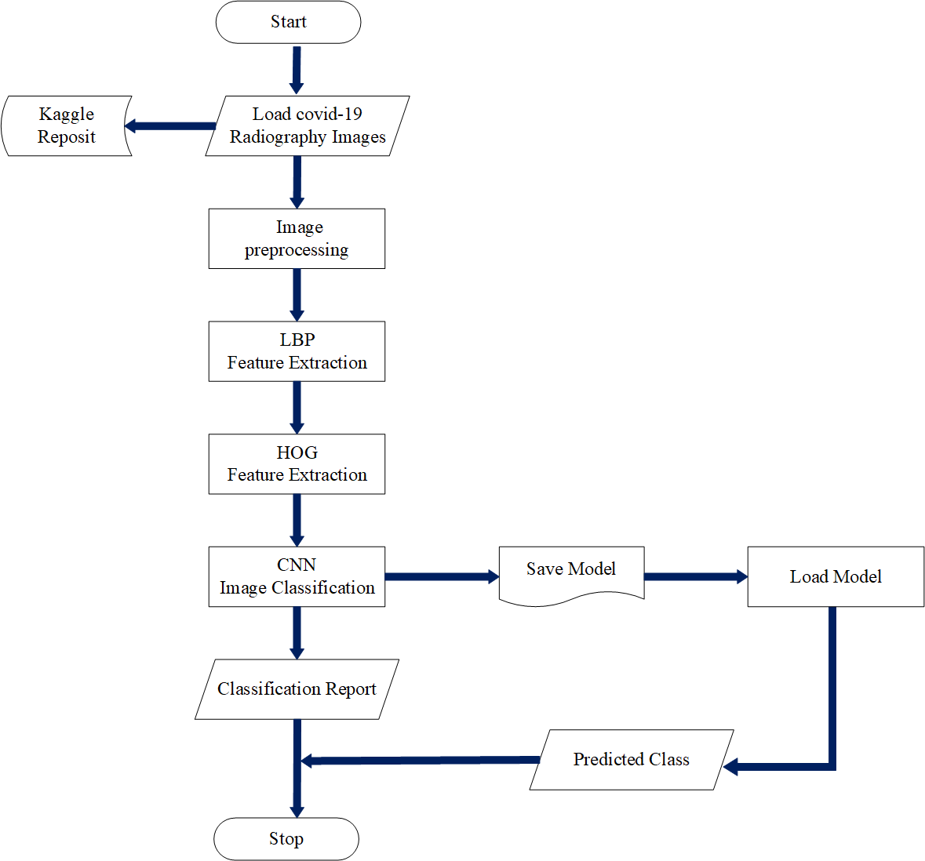

**Fig 3.1. HOG-LBP CNN based convid-19 classification data flow model**

Furthermore, based on the **fig 3.1** below diagram indicate the procedure taken and dataflow from the starting point to the terminating point. Covid-19 Radiograph Images are loaded flow either an online repository (directly) directly or from your local storage Had disk as input. Image are feed into the preprocessing stage, this stage includes image rescaling, dimensionality reduction, conversion of images into gray scale image, and image standardization. The next step is to forward the preprocessed images into the first layer of feature extraction using the Local Binary Pattern (LBP) feature extraction techniques and next extraction layer uses the Histogram of Oriented Gradient (HOG). After feature extraction image dataset are forwarded to the Convolutional Neural Network (CNN) deep learning algorithm. The CNN perform what is call Convolution for automatic feature extraction and either Max or Average Pooling in other to reduce image dimensionality. Fully processed images can now be forwarded to the deep neural network for classification. The model classification report is collected, viewed or save for prediction and deployment purpose. Then finally the program terminated.

**3.3 Data Collection**

This scientific research work will be gathering and collecting the Covid-19 Radiography image data form a popularly online data science community called Kaggle. The Kaggle repository is one of the biggest or largest data science community for machine learning practitioners. Its known to be a subsidiary of the LLC Google. (Casper et al., 2020) specifies in is research work that the Kaggle repository is an environment for dataset scientist to carry out research work, recruiting, proposing, identification and solving of scientific problems. Hence, this research work will consider the Kaggle repository for data collection. The Covide-19 Radiography image dataset consist of four classes of X-ray image dataset, this includes; the covid-19 X-ray sample images, Normal X-ray sample images, and finally, the Pneumonia X-ray sample images. The covid-19 image sample consist of 3916 X-ray image samples, 10192 of Normal X-ray scan images and Pneumonia consist of 1342 data samples. Based on the data the Normal Image X-ray Scan consist of the highest number of image sample, and 15153 total Radiography image sample is available for training purpose.

**Table 3.1 The Radiography X-ray image samples (Covid-19 X-Ray Scan samples).**

Considering the table below show 12 sample out of the 3916 total covid-19 X-ray scan sample the image is of PNG format with image size and dimensionality of (299,299, 3).

|  |  |  |
| --- | --- | --- |
|  |  |  |
|  |  |  |
|  |  |  |
|  |  |  |

**Table 3.2The Radiography X-ray image samples (Normal X-ray Scan samples).**

The table 3.3 consist of 12 sample of Normal case X-ray Scan sample out of the total sample of 10192 downloaded from Kaggle. Images samples are all of PNG format and 299 by 299 in dimensionality.

|  |  |  |
| --- | --- | --- |
|  |  |  |
|  |  |  |
|  |  |  |
|  |  |  |

**Table 3.3 The Radiography X-ray image samples (Pneumonia X-ray Scan samples).**

In respect to the table below show the sample of Pneumonia X-ray scan sample from the total scan image of 1342 images, download in Portable Graphic Network Format with 299 by 299 dimension.

|  |  |  |
| --- | --- | --- |
|  |  |  |
|  |  |  |
|  |  |  |
|  |  |  |

**3.3 Feature extraction**

The feature extraction in image processing encompass dimensionality reduction of image, in which the raw image data is normalize to make image processing easier. Feature extraction are information or data extracted from the original raw data for improving machine learning understanding and easier processing. The feature extraction stage is essential or of utmost important in situation where the image dataset is large, high in dimension or quality that is needed to be reduce without actually losing any essential or relevant information. Feature extraction also help in eliminating redundancy in a dataset. In respect to this research work adopt two feature extraction techniques are considered, this includes; the Histogram of Oriented Gradient (HOG) and Local Binary Pattern (LBP) feature extractor.

**3.3.1 Local Binary Pattern**

The Local Binary Pattern (LBP) is a very popular feature extraction techniques in images, which is frequently used in solving real word problems. The local binary pattern techniques his a very simple, and efficient image extraction operator. Hence, the computational complexity of local binary pattern the very low and this enable the LBP techniques work efficiently even in a complicated and in real time application processing. It is also generally termed has an approach that is unified to statistical and traditional structural models. The LBP techniques or method defines the area of each pixel of a particular image and then assign a label to these pixels using binary numbers. The articulation of LBP can be represented in a decimal form given a pixel at location (Xc, Yc) using the below equation (Wei et al., 2019)(Neighbor et al., 2021).

*LBPP, R* (XC, YC) = ……………………...…………………………. Eq (3.6)

In respect to equation 3.6 the ic ­and ip  denote the gray level value in the center pixel of the image and P in the above equation expresses the surrounding pixels within the circle neighborhood with the radius of R. however, the function of S(x) is express mathematically as (Neighbor et al., 2021).

S(x) = ……………………...……………………………………. Eq (3.7)

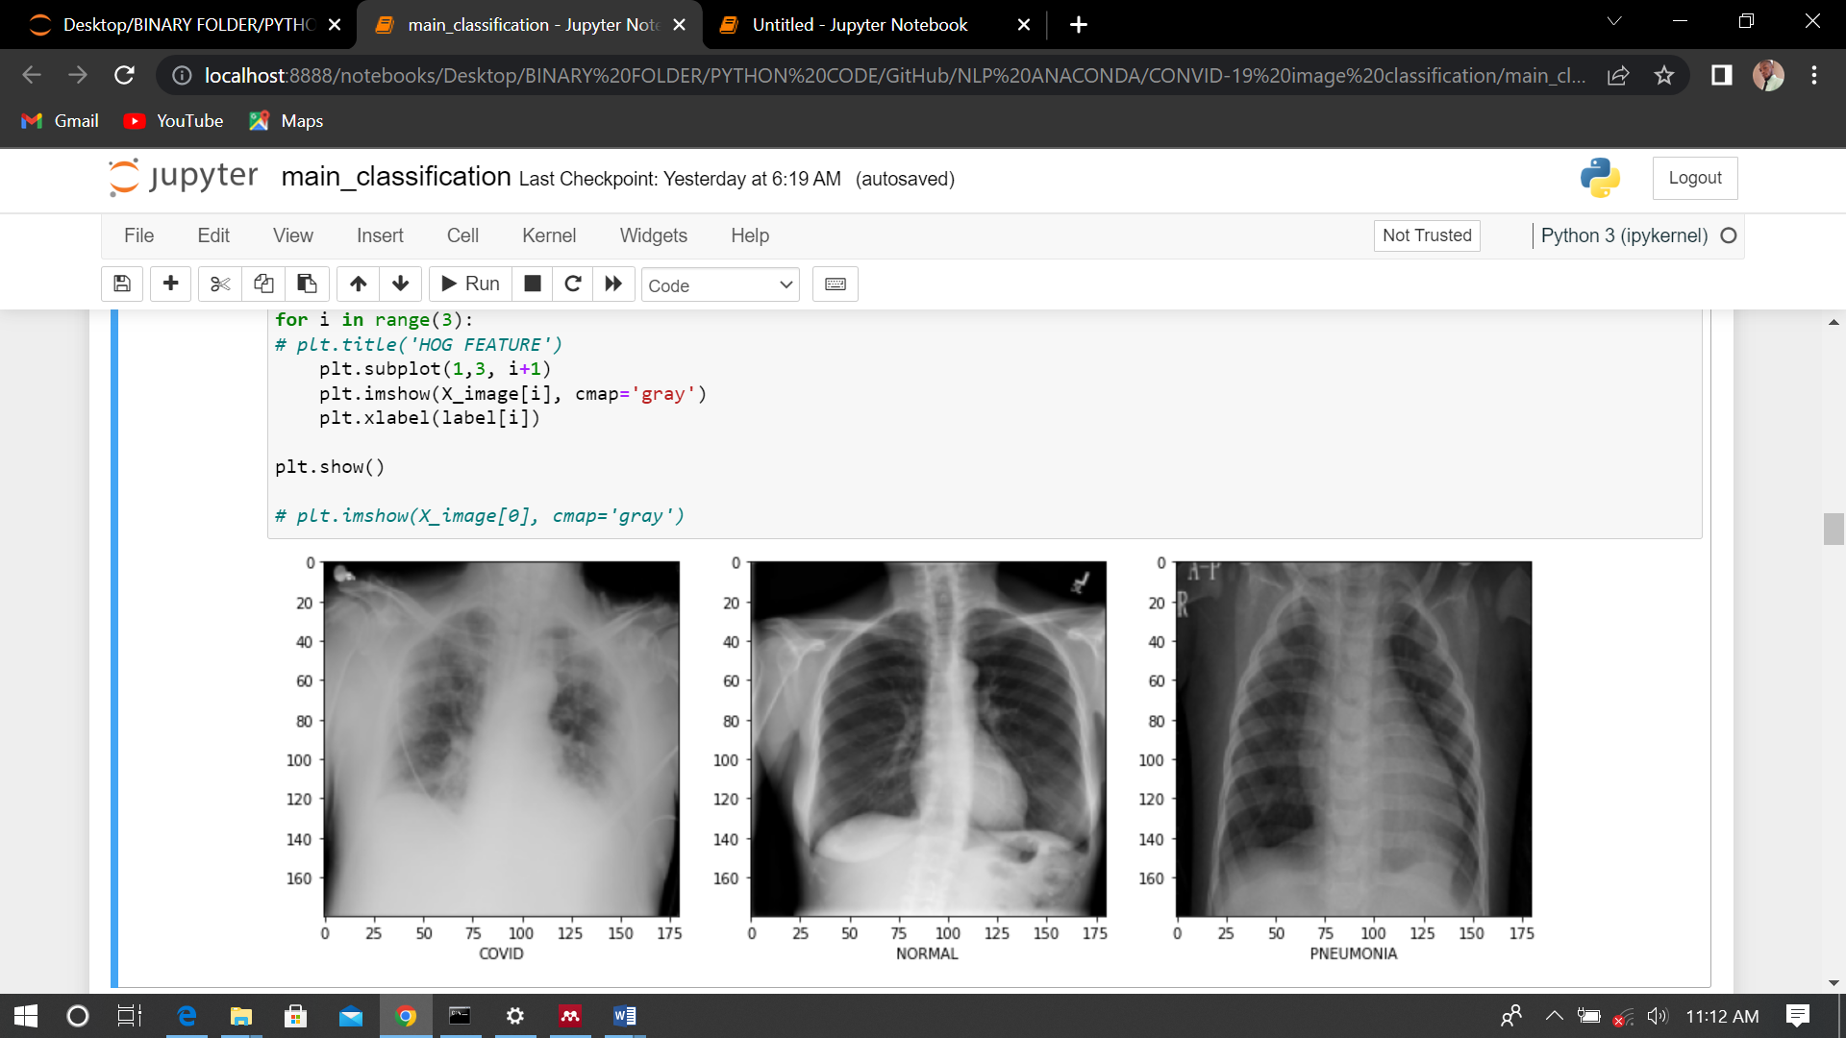The LBP techniques is applied to the raw 15153 images. Below are the visualize image using PyPlot library in python.  One instance of image from each classis are display below

**Fig 3.2 The raw image samples from each classes (Covid-19, Normal and Pneumonia case)**

Considering the figure 3.2 above show sample X-ray image scan from the Covid-19, Normal and Pneumonia cases before performing Local Binary Pattern (LBP) feature engineering.

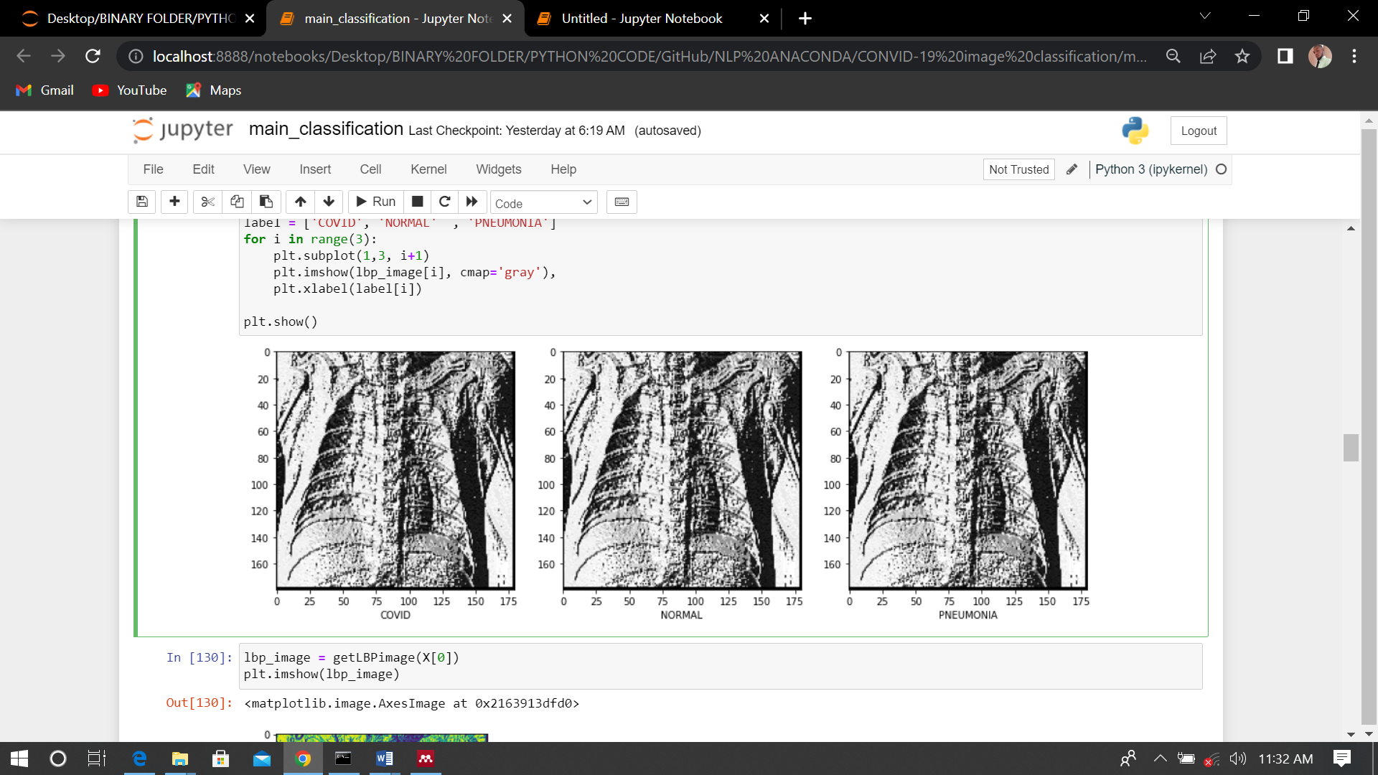

**Fig 3.3 The LBP image samples from each class (Covid-19, Normal and Pneumonia case)**

**3.3.2 Histogram of Oriented Gradient**

The Histogram of Oriented Gradient is feature extractor form images popular refers to as HOG. The HOG techniques for feature descriptor is popularly used in the field of image preprocessing and computer vision. The techniques his used in performing a very complex image detection and recognition task, it helps in removing redundant data without losing important information. Computational cost in training images is reduced using HOG (Marufur et al., 2021). This research work use Histogram of Oriented Gradient to extract important information from Covid-19, Pneumonia and Normal Radiography X-ray Scan in other to improve deep learnings classification. In HOG the features used are the histograms of orientations of gradients. The Gradient, thus the direction of X and Y are important for representing a complex shape (corners and edges). The directions of the a given gradient denote the direction in change of pixel intensity of the image. For instance, given and image of *f*(x,y) the gradient of that image can be mathematically expressed as (Marufur et al., 2021).

∆*f* =  = ………………………………………………. Eq (3.1)

Considering the equation above, the is known as the derivative of the image in respect to ‘x’ and is the derivative of the image in respect to ‘y’. then finally the derivative can be further computed using this following equation.

*f*x(x) *=*  = *f* (x +1) - *f* (x -1) ………………………………………………. Eq (3.2)

*f*y(y) *=*  = *f* (y +1) - *f* (y -1) ………………………………………………. Eq (3.3)

practically, the calculated derivative is computed by convoluting the images in conjunction with x- and y-axes using the kernels [-1 0 1] and . after the gradient has been computed the direction and magnitude of the calculated gradients can now be computed using the below equation or formulas (Marufur et al., 2021).

g = ……………………...……………………………………………. Eq (3.4)

θ = tan-1  ……………………...……………………………………………. Eq (3.5)

However, the resulting featured extracted image using the Histogram of Oriented Gradients of each sample in the Covid-19, Normal and Pneumonia class. The output image from each class case is displayed below, one sample each from each class out of the total 15153 Radiography X-ray Scan images.

Base on the figure 3.4 below show the resulting images sample of Covid-19 case, normal case and Pneumonia X-Ray scan image using the Histogram of Oriented Gradients. The HOG feature extraction techniques are performed on all the 15153 image samples downloaded.

**Fig 3.4 The feature extracted image using HOG (Covid-19, Normal and Pneumonia case)**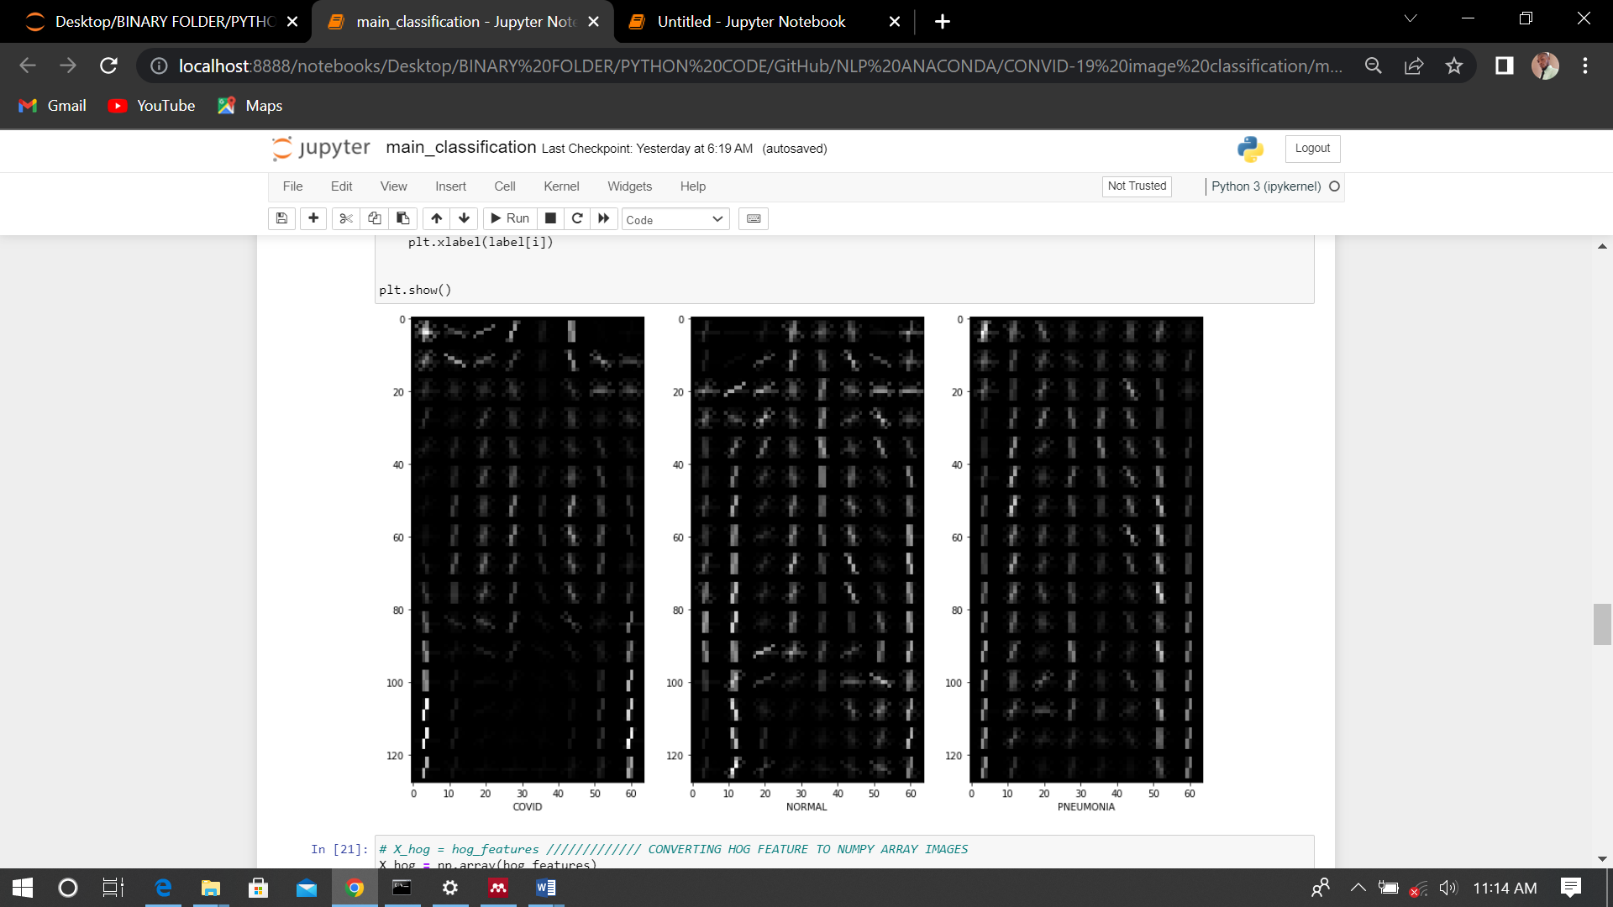

**3.4 Covid-19 Radiography Dataset**

The covid-19 dataset is collated by a team or group of researchers from the university of Qatar, Doha and Dhaka University, Bangladesh along with is teams from Malaysia and Pakistan collaborated with medical practitioner (doctors) in other to crate the chest X-ray Scan images for that of

1. Covid-19 positive cases
2. Normal Image case
3. Pneumonia Images case

However, the normal or other lung infections dataset along with the covid-19 dataset are been released in stages. 219 covid-19 images were first release, 1341 images scan of normal cases and 1342 pneumonia virial chest X-ray (CXR) images. After the first update made to the first dataset release in stage one, the covid-19 image X-ray scan increase to 1200 images, and now the second update and increase the dataset of covid-19 image 10 3616 along with Normal case of 10,192 dataset. The No-covid-19 infection of the lung thus, the lung opacity consists of 6012 and 1342 viral Pneumonia image and their corresponding lung mask. the dataset are collected from different source as listed below

1. Normal Image scan: The dataset is collated from two different sources

* 8851 images are collected from RSNA
* And 1341 Scan images from Kaggle Repository

1. The Covid-19 data: Covid-19 image Scan dataset set are gathered form two different public accessible dataset which includes published papers and online sources

* 2473 image of CXR are gathered form padchest dataset
* 183 images of CXR are from the medical school in Germany
* 559 CXR images also from Tweeter, Kaggle, Github, and SIRM
* 400 CXR images from other sources on Github.

1. The Viral Pneumonia images

* 1345 Pneumonia data are been collected from the Chest X-Ray images of (Pneumonia) dataset

**3.4.1 Convolution Neural Network**

The Convolutional Neural network popularly called CNN or ConvNet are deep neural network that mostly used in the area or field of computer vision and image processing task. The CNN’s network mimics the behavior of biological process where pattern of neuron is fully connected just like the biological neuron system. Convolution neural network learn automatically by extracting features automatically, this require little or no preprocessing in comparison to that of image classification algorithm. Convolution is known as transformation operation in respect to the field of image processing where small part of the matrix from the main image matric are filter out, the filtered matric are called Kernel which is passed over to an image and they average weighted value are calculated. Below Is the mathematical representation of convolution 2D space (Marufur et al., 2021).

y = …………. Eq (3.6)

based on the above equation 3.6 the ‘x’ and ‘k’ are considered as the inputted image and the convolution kernel. The ‘y’ denote the convolution process or operation that exist between the result in the output image. The (m, n) and (i , j) index specifies the width and the height of the kernel and the inputted image. Generally, Convolution network perform shrinking on the inputted image and various type of padding operation are used in other to facilitate the convolution operation on the entire image. Another import parameter of a convolution is the stride, which denote the number of pixel the kernel covers or moves after every convolution operation. However, in deep learning images are reshape to equal height and width. Hence, kernel is designed to have equal width and height(Marufur et al., 2021).

**3.4.2 Exploratory Data Analysis**

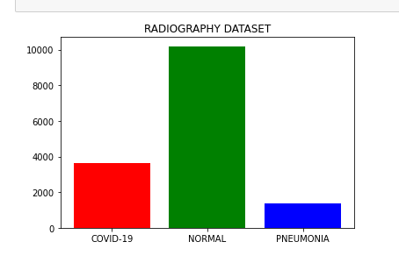The Covid-19 Radiography Dataset consist of Covid-19, Normal, Lung Opacity and Pneumonia Chest X-ray images and their corresponding mask images. However, based on the research the Covid-19, Normal and Pneumonia chest X-ray image datasets is considered. The covid-19 image folder consists of 3616 images, the Normal case dataset includes 10192 image samples, and the Pneumonia scan image consist of 1342 images. In consequences this result to a total image of 15153 image used in training the proposed LBP-HOG-CNN model. a visual glance at the count of each sample classes (covid-19, pneumonia, normal) using bar chart.

**Fig 3.5 Radiography image count for Covid-19, Normal and Pneumonia dataset.**

based on the fig 3.5 which depict each class count using the bar chart diagram. The red bar denotes the covid-19 and it can be clearly seen at a glance that the number of covid-19 image is approximately 4,000 images. While the Normal cases depicted using the green, it can be easily deduced that the Pneumonia images is the smallest dataset with approximately 2,000 images. And finally, the Normal case denoted with a blue bar shows that this class consist of the highest images dataset of approximately 10,000 X-ray scan images.



**Fig 3.6 One sample from each class (Covid-19, Normal, and Pneumonia).**

**3.4.3 Training and Validation dataset**

the testing and validation is the processes of splitting the entire dataset into two (training and testing data). This is essential to train the deep neural network with the training data in other to efficiently classify covid-19 images from that or Normal and Pneumonia data image and vice versa. Hence, the testing data images will be used to test or validate the accuracy, strength and performance of the deep learning model. this paper work consists of total images of 15153, and the dataset will be split into 72% percent training data and 25% percent testing or validation data. This result to 11364 training data and 3789 testing or validation data.

**3.5 LBP-HOG-CNN Classification Architecture**

Based on fig 3.7 The propose Local Binary Pattern and Histogram of Oriented Gradient for feature extraction and classification using convolution neural network, is depicted using the conception diagram below. In respect to the diagram below raw images of all 15,153 with dimension of 299 by 299, are feed into the Local Binary Descriptor (LBP) for feature extraction with the image shape or dimension of (180 by 180). The output feature extracted of images using LBP are further engineered using the Histogram of Oriented Gradient (HOG) and it required the image to be first reduced into 128 by 64-dimension images. Furthermore, the output image from the HOG feature descriptor are now feed into the coevolution layer along with is max pooling layer for further dimensionality reduction. This propose model used four convolutional and max pooling layers before forwarding the output image to the flatten layer. The flatten layer is essential in other to covert the 2-Dimensional images (128,64) to a 1-Dimensional image (8192). Finally, the images can now be feed into the neural network for training and classification. All other layer apart from the output layer with 4 neurons uses ReLu as the Activation function, while the output layer uses sigmoid function for activation.

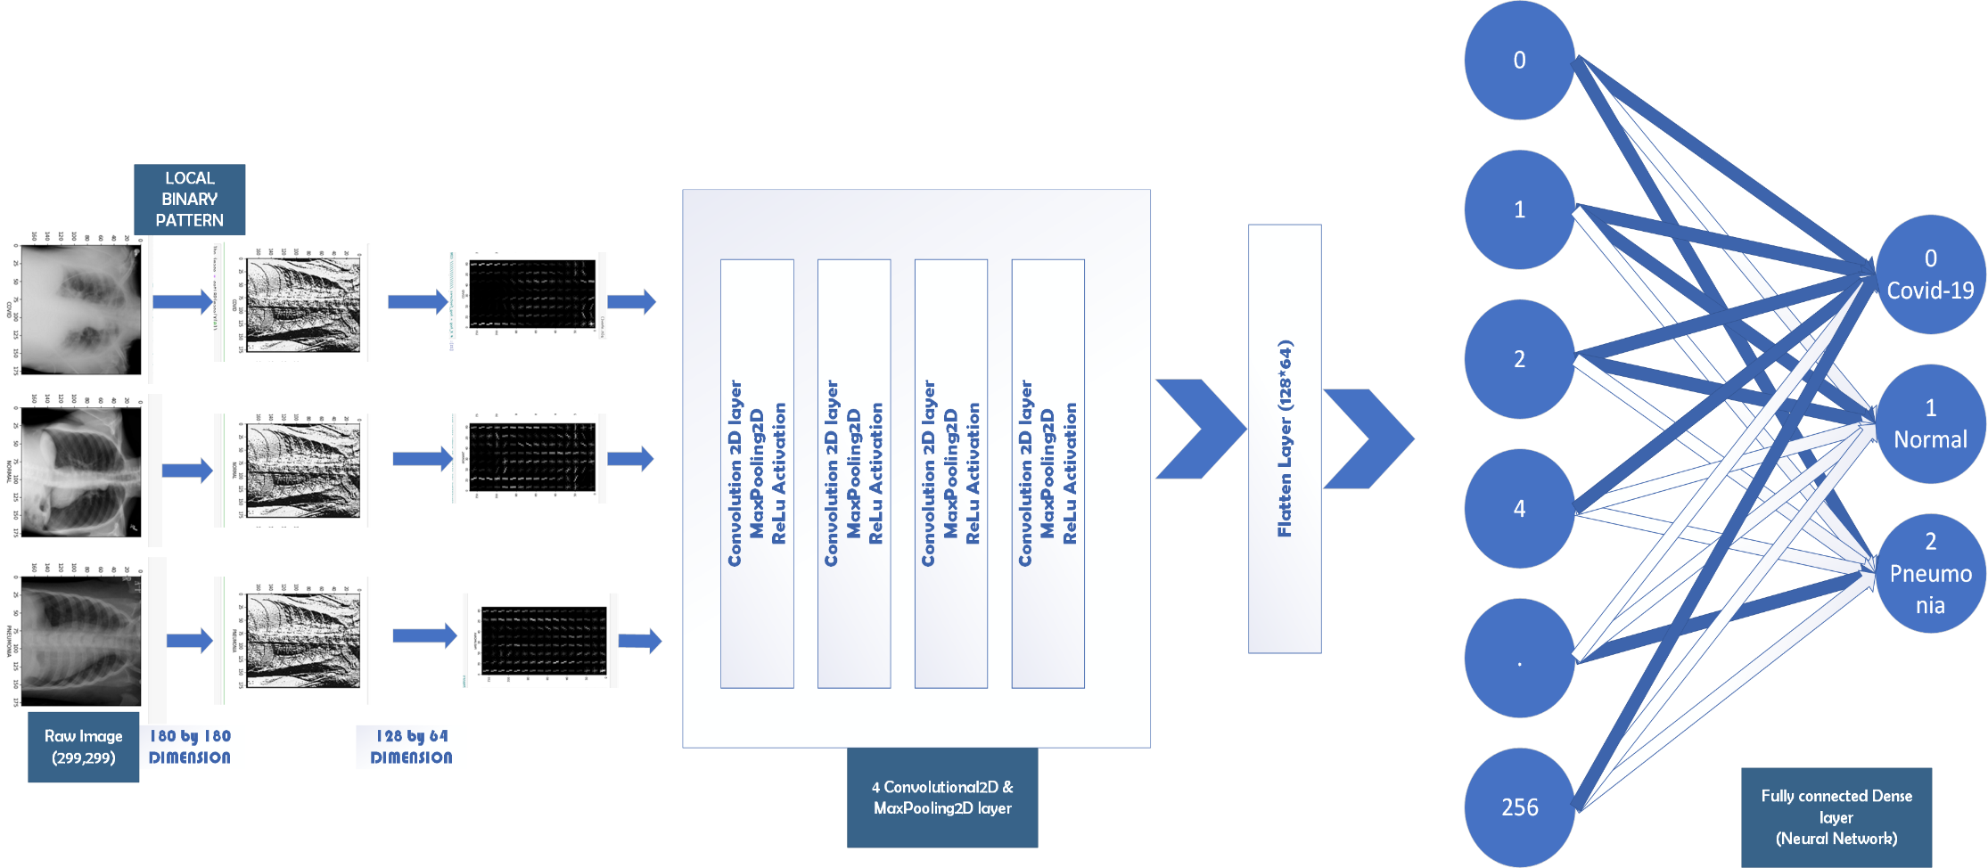

**Fig 3.7 Proposed LBP-HOG-CNN Covid-19 Radiography Image Classification Model**

**3.6 System Requirement**

The proposed model design was carried out on a system with hardware specification of Core i5 4th Generation intel processor of 2.60GHZ Speed. The installed memory (RAM) is 8GB and 64bit window 10 operating system.

**3.7 Programming language**

the choice of programming language is python. Due to is widely used in the area or field of Artificial Intelligent (Machine learning and Deep Learning) and it contain ready-made module to perform AI, ML, and DL task. Python is a high-level object-oriented programming language. Python version 3.9.0 his specifically used and the choice of development environment is Jupiter Notebook. Finally, Microsoft Visual Visio is used in design all conceptual diagrams for the proposed model.

**Reference**

Casper, B., Bojer, S., & Meldgaard, J. P. (2020). *Learnings from Kaggle ’ s Forecasting Competitions*.

Marufur, M., Sheikh, R., Azharul, N. K. M., Nahin, H., & Dey, K. (2021). HOG + CNN Net : Diagnosing COVID ‑ 19 and Pneumonia by Deep Neural Network from Chest X ‑ Ray Images. *SN Computer Science*, *2*(5), 1–15. https://doi.org/10.1007/s42979-021-00762-x

Neighbor, K., Machine, S. V., Knn, H.-, Lbp-knn, T., Covid-, T., Tomography, C., Covid-, T., Ii, W. W., Economic, W., & Report, O. (2021). *Results in Physics chest X-ray images*. *31*(November), 0–7. https://doi.org/10.1016/j.rinp.2021.105045

Wei, X., Yu, X., Liu, B., & Zhi, L. (2019). Convolutional neural networks and local binary patterns for hyperspectral image classification. *European Journal of Remote Sensing*, *52*(1), 448–462. https://doi.org/10.1080/22797254.2019.1634980